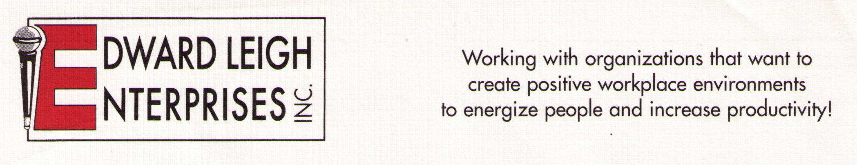

P O Box 18819  Cleveland, OH 44118-0819
440-338-3056 / 1-800-677-3256  FAX 440-338-3076

Edward@EdwardLeigh.com  www.EdwardLeigh.com

Joy on the Job

Creating a Positive Workplace Environment

By Edward Leigh, MA

Program Description

A happy workplace is a productive workplace! This high-energy program will help you STICK to it. STICK stands for Stress Management, Teamwork, Inspiration, Communication and Kindness. The five key ingredients in this recipe create energized individuals and groups. This program is guaranteed to jump start your workplace!

Program Objectives:

1. Analyze methods to reduce stress.
2. Describe strategies to enhance teamwork.
3. Review methods of inspiring others.
4. Describe effective modes of communication.
5. Review top method to increase level of compassion (kindness).

Program Outline

Decreasing Stress

Monitoring stress levels for optimal performance

Developing a system to cope with stress

Enhancing Team Building

Reviewing methods which enables a team to achieve their goals

Examining the stages involved in team building including clarifying the goal, identifying the inhibitors and removing them.

Inspiring People

Determining effective methods of rewarding behavior

Motivating people to achieve their goals

Communicating More Effectively

Practicing effective listening skills to enhance communication

Using questions to obtain important information

Increasing Our Level of Kindness

Reviewing empathic responding as a tool to connect with people

