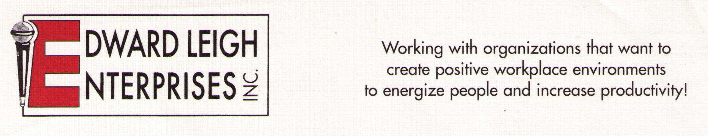

P O Box 18819  Cleveland, OH 44118-0819
440-338-3056 / 1-800-677-3256  FAX 440-338-3076
Edward@EdwardLeigh.com  www.EdwardLeigh.com

Newspaper and Magazine Interviews

*** The focus is always on the needs of the readers! ***

Interviewing Edward Leigh

Edward Leigh will help you create a dynamic reader-focused article through:

Learning about your reader demographics

Providing many great tips
- Avoiding unfamiliar jargon or technical language
- Offering additional resources

Photos

Our photo emailed to you; let us know:
- What format you would like the photo (e.g., jpeg)
- Type of photo (e.g., headshot)

Your photo taken by a newspaper / magazine photographer
- Photo shoot done in studio or in other setting (e.g., home, office, etc.)
- Contact our office to arrange convenient time for photo shoot

Sample Topics

Workplace / Life Skills
- How to Get and Stay Motivated
- Stress Management: Keeping it Together When You Feel Like Falling Apart
- Men, Women & Communication: Understanding Gender Differences
- The Likeability Factor: Ways to Make It Work For You
- Making a Great First Impression!
- Making Work Fun!
- Learning How to REALLY Listen

Health (Edward Leigh is a healthcare professional – Masters Degree in Health Education)
- Taking Charge of Your Healthcare (Becoming Your Own Advocate)
- Using the Internet to get LEGITIMATE Health Information
- Cancer Survivorship Topics (please contact us for a complete list of topics)

