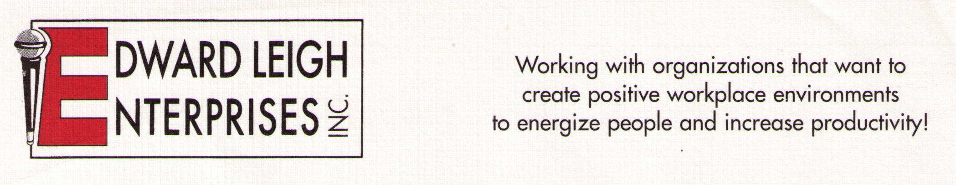

P O Box 18819  Cleveland, OH 44118-0819
440-338-3056 / 1-800-677-3256  FAX 440-338-3076
Edward@EdwardLeigh.com  www.EdwardLeigh.com

Television Interviews

*** The focus is always on the needs of the viewing audience! ***

Before the Interview

Edward Leigh will consult with the radio station in regard to:

Viewing audience demographics

Length of interview
- Submission of pre-interview questions
- Whether the show will be live or taped
- Single or multiple guests
- Location of interview

During the interview
Edward Leigh has been interviewed on hundreds of television stations. During the interview you can expect from Edward Leigh:
- Professional, well-prepared and friendly demeanor
- Appropriate attire with TV-friendly colors and styles
- Points delivered in “sound byte” format
- A high-energy and lively discussion
- Lots of great tips for viewers
- No unfamiliar jargon, technical language or “verbal pauses” (e.g., “ums”)

Sample Topics

Workplace / Life Skills
- How to Get and Stay Motivated
- Stress Management: Keeping it Together When You Feel Like Falling Apart
- Men, Women & Communication: Understanding Gender Differences
- The Likeability Factor: Ways to Make It Work For You
- Making a Great First Impression!
- Making Work Fun!
- Learning How to REALLY Listen

Health (Edward Leigh is a healthcare professional – Masters Degree in Health Education)
- Taking Charge of Your Healthcare (Becoming Your Own Advocate)
- Using the Internet to get LEGITIMATE Health Information
- Cancer Survivorship Topics (please contact us for a complete list of topics)

