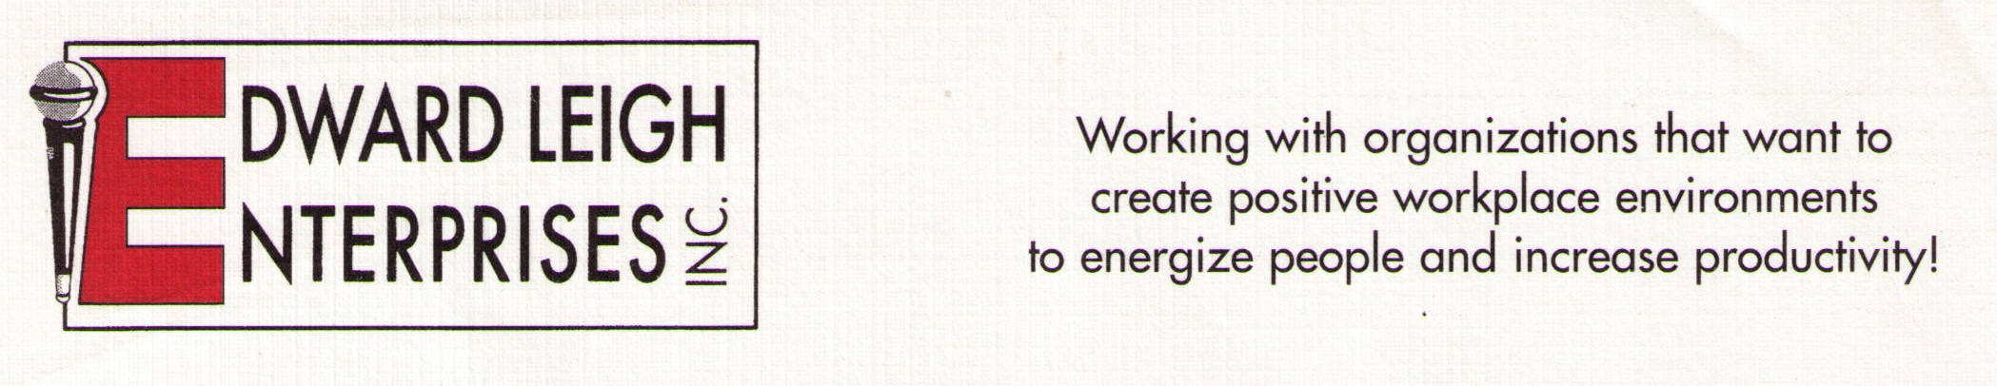

P O Box 18819  Cleveland, OH 44118-0819
440-338-3056 / 1-800-677-3256  FAX 440-338-3076
Edward@EdwardLeigh.com  www.EdwardLeigh.com

Communicating with Patients

What Every Healthcare Professional MUST Know!

Program Description

This high-energy interactive program will empower healthcare professionals with skills to dramatically improve the quality of interactions with patients and co-workers. This will lead to improved patient compliance and decreased workplace stress. The workshop will allow participants to practice listening, empathy and questioning techniques. Communicate your way to success!

Program Objectives:

1. Review nonverbal communication styles.
2. Examine active listening skills and barriers to effective listening.
3. Review appropriate uses of questions.
4. Review empathic responding as a means of interacting with patients.

Program Outline

- Review nonverbal communication styles.
  - Nonverbal enhancements to language symbols
  - Nonverbal symbols of body movement
- Examine active listening skills and barriers to effective listening.
  - Listening tips to dramatically improve communication
  - Communication barriers that inhibit listening
- Review appropriate use of questions.
  - Open- vs. closed-ended questions
  - Best times in conversations to ask questions
- Review empathic responding as a means of interacting with others.
  - Empathy vs. sympathy
  - Styles of empathic communication

