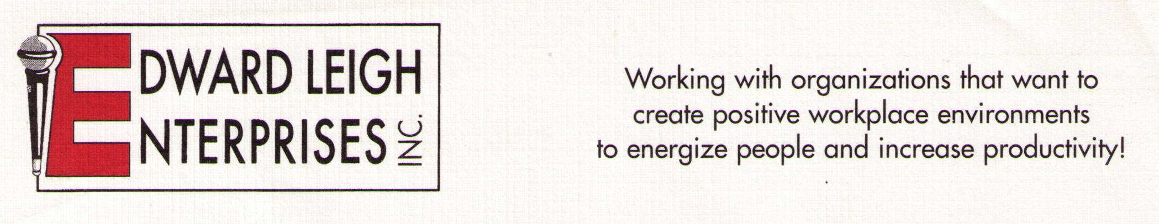

P O Box 18819 l Cleveland, OH 44118-0819
440-338-3056 / 1-800-677-3256 l FAX 440-338-3076
Edward@EdwardLeigh.com l www.EdwardLeigh.com

High Impact Communication

Top Tips for Terrific Connections!

By Edward Leigh, MA

Program Description

This high-energy interactive program will empower people with skills to dramatically improve the quality of interactions with others, which will lead to decreased stress and increased compliance. The workshop will allow participants to practice listening, empathy and questioning techniques. This program contains bonus sections on resolving communication conflicts and powerful methods of enhancing email correspondence. Communicate your way to success!

Program Objectives:

1. Review nonverbal communication styles.
2. Examine active listening skills and barriers to effective listening.
3. Review appropriate uses of questions.
4. Review empathic responding as a means of interacting with others
5. Handling and resolving communication conflicts.

Program Outline

- Review nonverbal communication styles.
  - Nonverbal enhancements to language symbols
  - Nonverbal symbols of body movement
- Examine active listening skills and barriers to effective listening.
  - Listening tips to dramatically improve communication
  - Communication barriers that inhibit listening
  - Open- vs. closed-ended questions
- Review appropriate use of questions.
  - Open- vs. closed-ended questions
  - Best times in conversations to ask questions
- Review empathic responding as a means of interacting with others.
  - Empathy vs. sympathy
  - Diagnosis- vs. person-focused approach
  - Styles of empathic communication
- Handling and resolving communication conflicts.
  - Identifying issues
  - Listing solutions and evaluating options
  - Selecting best option and finding agreement

