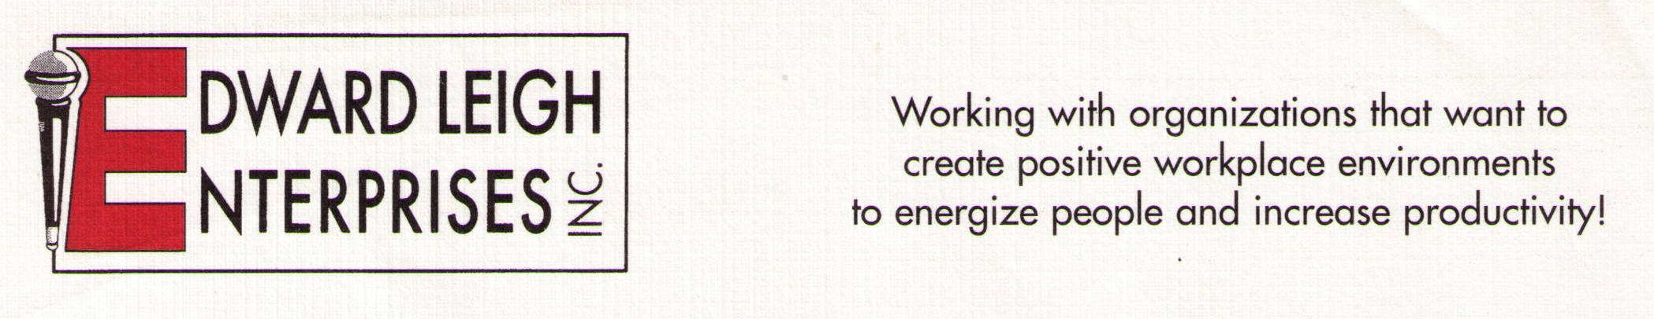

P O Box 18819  Cleveland, OH 44118-0819
440-338-3056 / 1-800-677-3256  FAX 440-338-3076
Edward@EdwardLeigh.com  www.EdwardLeigh.com

Stress Management

Workplace Strategies to Dramatically to Enhance Productivity

Program Description

High workplace stress translates into decreased job effectives. This energizing and interactive program includes best practices to have a more productive “less stress” workplace. The program begins with an exploration of how stress perception influences how we cope. The majority of the programs centers around practical tips to manage the debilitating effects of stress. The program concludes with well-researched strategies on life balance. Come prepared for an invigorating experience!

Program Objectives:

1. Review how perception of stress influences outcomes.

2. Analyze different methods of stress management
3. Describe the four key components in life balance

Program Outline

- Perception of stress
  - Understanding stress levels and their influence.
  - Comprehending what we can change

- Methods of stress management
  - Anticipating Stress

Avoid Negative Thinking / Thought Awareness

Positive Thinking / Affirmations
  - Meditation / Guided Imagery

Physical Exercise

Time Management / Organizational Skills

Determining significance.

- Key components in life balance
  - Mental/intellectual
  - Social/emotional
  - Spiritual
  - Physical

